TEST PROJECT
IT SOFTWARE SOLUTIONS
FOR BUSINESS

module 5

wSC2017_TP09_m5_actual

Submitted by:
WorldSkills International
Independent Test Project Design Team

Contents
This Test Project proposal consists of the following documentation/files:
- WSC2017_TP09_S5_EN.pdf (Session 5 instructions)
- Session5-MySQL.sql (SQL script to create tables with data for MySQL)
- Session5-MsSQL.sql (SQL script to create tables with data for Microsoft SQL)
- CaseStudy.pdf (Case study provided by a department of the airline)
- TestingTemplate.docx (Testing template to be completed for session 5)
- ReservationSystem.exe (Working copy of the reservation system)

Introduction
In order to improve flight experience on AMONIC Airlines and provide a better experience, the airline has decided to offer some amenities to passengers.
There will also be requests for diagrams and technical testing of the reservation system as provided.
The following are the main functionalities executed in this session:
- Allow the passengers to purchase amenities.
- Create reports based on flight numbers and flight dates.
- Test a working copy of a software and provide a report of the results based on provided queries.
- Provide diagrams for the analysis of the case study provided.

Description of project and tasks
In submitting your solution, please make sure the deliverables conform to the basic guidelines drawn out by different departments at AMONIC Airlines:
- There should be consistency in using the provided style guide throughout development.
- All required software modules must have applicable and useful validation and error messages as expected by the industry.
- The use of valid and proper naming conventions is expected in all material submitted.
- Any form or report once created should be displayed in the centre of the screen.
- When a form or a dialogue is in focus, operations on other forms need to be suspended.
- The caption of Delete and Cancel buttons need to be in red to help with accidental mishaps.
- When using colours to differentiate between rows or records, there needs to be visible clarification on the screen as to what they stand for.
- The wireframe diagrams provided as part of this document are only suggestions and the solution produced does not have to be, in any way, mirror what has been pictured.
- Time management is critical to the success of any project and so it is expected of all deliverables to be complete and operational upon delivery.

Instructions to the Competitor

5.1 CreatING the database
Create a database by the name of “Session5” in your desired RDBMS Platform (MySQL or Microsoft SQL Server). This will be the main and only database you will use in this session.

5.2 ImportING database structure
Depending on your preferred RDBMS platform, a SQL scripts is made available. The said scripts consists of the database structure and data required to complete the required tasks. The data needs to be imported to the database created for this session named “Session5”.
As instructed by the designers, the database structure provided for the purpose of this section cannot be altered. This applies to removal of tables, adding or deleting any fields on the tables or of change in their data types.
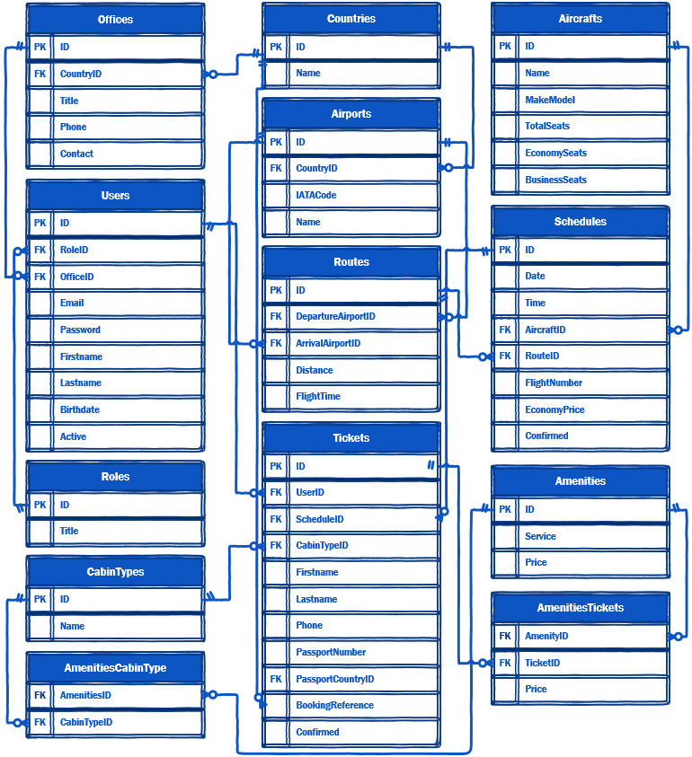
To help further perceive the thinking behind the structure of the database, the database designers provide an Entity-Relationship Diagram (ERD). The aforementioned diagram explains the conceptual and representational model of data used in the database.

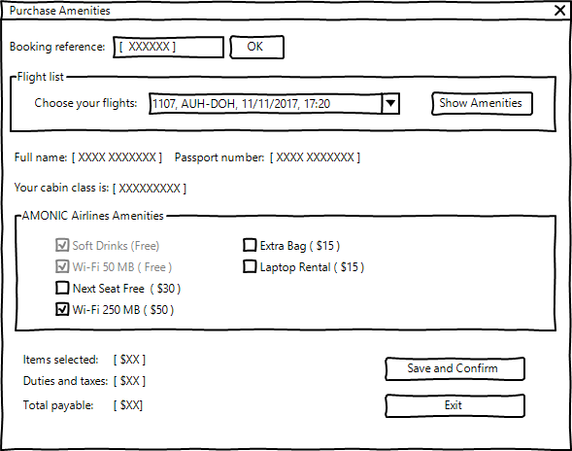

5.3 purchasing amenities
The passengers flying AMONIC Airlines can walk into any of their offices or call them up and ask for extra amenities for their upcoming flights.
The details of such system would entail the following technicalities:
- To retrieve booking information, the first thing the user needs to enter into the system is their booking reference number.
- By searching the database for the booking reference number, they will be presented with a list of flights registered for that booking. Here are some things to consider:
  - This service is available up to 24 hours before each flight. It goes without saying that it should not work for the flights that have already flown out.
  - The list should contain the flight number, date of the flight, and the departure and arrival airports.
  - The user can choose the flight they need to purchase amenities for with a button.
  - The user must be able to change their flight at any time and it should not require them to close the form and come back.
- When the flight is confirmed, these items need to be made available to the user:
  - The cabin class, full name, and the passport number of the passenger needs to be shown for the representative to verify the correct booking.
  - List of the available amenities are retrieved from the database and shown to the user.
  - The items that are free (included as part of the cabin type) cannot be purchased.
- The form should also update the total payable amount in this way:
  - The total of all the items selected should be displayed as an item on the screen.
  - The duties and taxes will show how much the 5% value added tax will add to the amount.
  - Total payable is the sum of the extra charges for the selected amenities.
- If the flight chosen for the booking already has amenities purchased for on the database, the form should display those amenities (checkmark against them) and allow the user to make changes to it.
  - The total payable should subtract the amount paid for the last purchase from the current total and only ask for the difference. (negative values must be marked as refund)
- There should also be an exit button and a save button positioned at the bottom of the form.

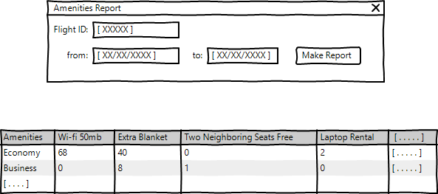

5.4 Report of amenities needed for flights
The management needs a report of the amenities required for each flight 24 hours before flying time. This is so that the crew can prepare to offer the amenities as the passengers have requested them. This is a short description of what the report entails:
- The report displays the results either using a filter that searches for certain dates and the total amenities associated with them or by asking for a flight number and date of the flight. In the case of the latter it will show amenities required for a single flight and in the former it will be for all flights leaving on the dates specified.
- The list should include the total of the number of each amenities.
- You may arrange the report elements and layout in any way you wish.

5.5 Testing software solution
The support desk at the airline has received complaints and bug reports for the reservation system from various offices. The list has now been compiled into a testing template.
By reading the varied scenarios as a software developer, you will need to run them on ReservationSystem.exe and record the rundown as requested.

5.6 designing and analyZing database (OVERDRIVE)
One of the departments in AMONIC Airlines has prepared a case study and has described the way they work. They need technical documents in the form of two diagrams.
There is no need to develop the database but only to present our software developers the printable material (in pdf) for reference. The diagrams previously made available as part of this session can be used as reference.

